Apprentice Training Supports Online:
Step by Step Instructions to Apply for Financial Supports

Change History
Date | Details of Change
April 2, 2012 | Job Aid Created
June 13, 2016 | Job Aid updated to include NCM Apprentices attending training Out of Province

Introduction:

In order to receive Financial Supports as an Apprentice, an application must be completed through the Apprentice Training Supports Online Portal. An application is required in order to determine a Client’s eligibility and as part of the approval process to collect Employment Insurance while attending Apprenticeship training. Below is a step by step guide on how to complete an application.

Once the Apprentice Financial Supports application is completed, the Apprentice must apply for Employment Insurance (EI) using the EI Reference code and await the decision regarding financial supports.

The application can be started from the WorkBC site at: https://www.workbc.ca/ under the Employment Services section or by going directly to the sub link URL: https://www.workbc.ca/Employment-Services/Apprenticeship-Training-Supports/Apprentice-Financial-Supports.aspx.

Section 1: Completing the Online Application for Apprentice Financial Supports

Step | Action
Access the Apprenticeship Training Supports section of the Work BC site at:
https://www.workbc.ca/Employment-Services/Apprenticeship-Training-Supports.aspx then click on the Access online apprentice financial supports link or click the direct link to the Apprentice application here:
https://www.workbc.ca/Employment-Services/Apprenticeship-Training-Supports/Apprentice-Financial-Supports.aspx
Click on the Apply Here button.

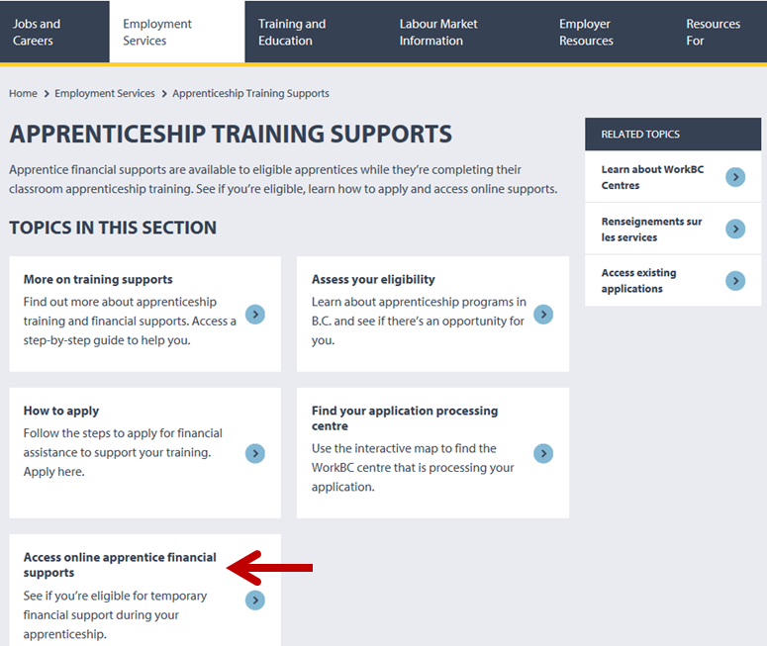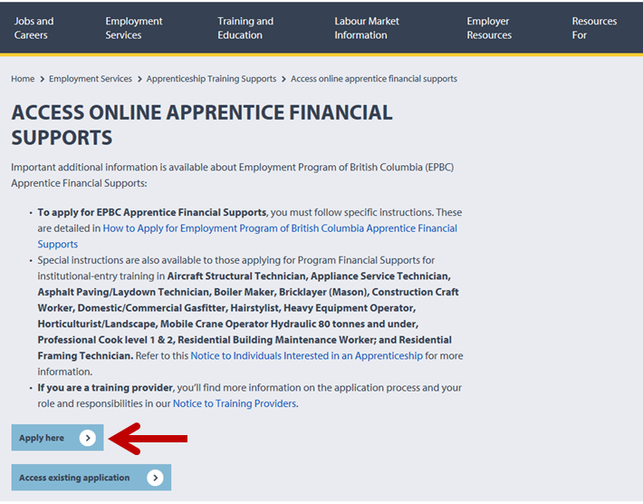

If you are attending a Training Institution in British Columbia, choose the applicable Training Institution for Apprentice training from the drop down menu and click GO

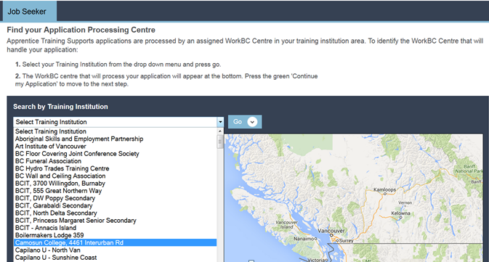

This will generate a map that displays the WorkBC Service Centre responsible for the area. Select the appropriate Centre then click the Continue my Application button. A page of additional resources available is displayed.

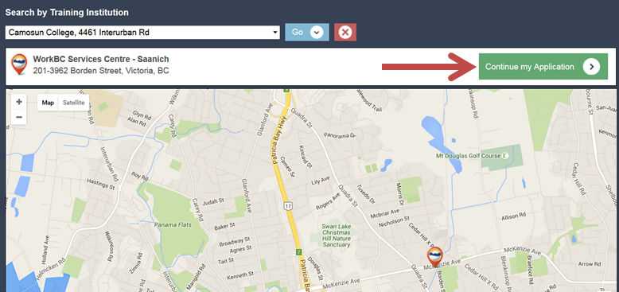

If you will be attending a Training Institution outside of the British Columbia, choose “Out-of-Province” as the Training Institute from the drop down menu and select GO.

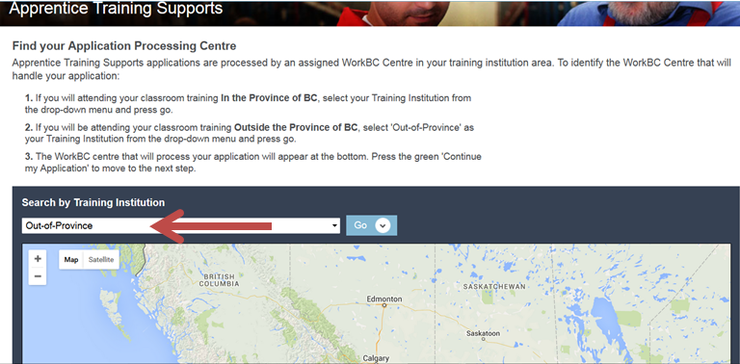

 | A pop up box will display requiring address and postal code. Enter your HOME postal code. This will generate a map that displays the WorkBC Service Centre responsible for the area. Select the appropriate Centre then click the Continue with my Application button. A page of additional resources available is displayed
To start the application, scroll down and click on the green Start button located below the video window.

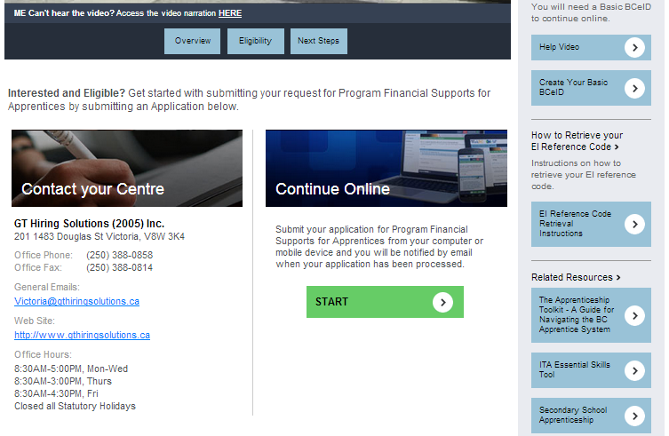

The user is taken to the Apprentice Training Supports Login screen. On this screen the user has options to Login and Continue using a valid Basic BCeID or Create a BCeID and Continue.

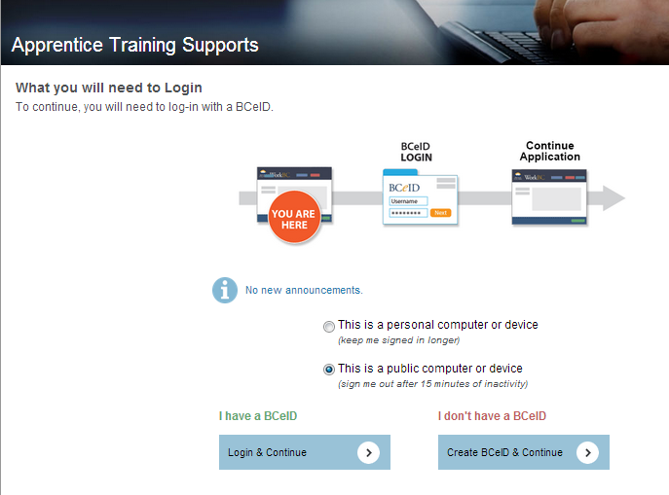

NOTE: A Basic BCeID is required to create an application for Apprentice Financial Supports. A Basic BCeID is a unique User Name and Password that allows users to securely submit and access information from government websites. It is free to create.

If you do not already have a Basic BCeID, follow Steps 4 and 5 below.
If you already have a Basic BCeID, proceed to Step 6.

In order to create a Basic BCeID

Click on the Create BCeID & Continue button

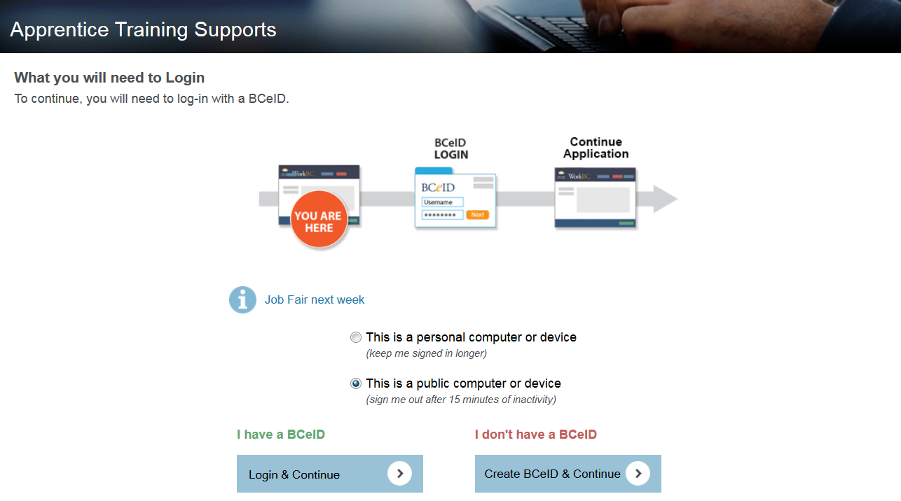

Click on the Visit the BCeID Site

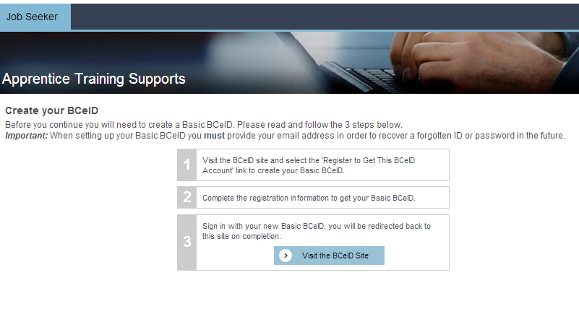

Click on the Register to Get This BCeID Account hyperlink:

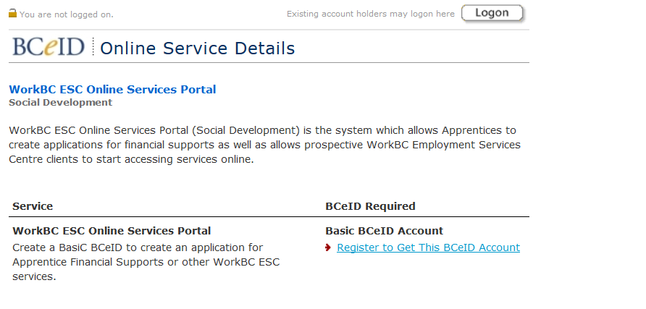

Complete the information required to register for a Basic BCeID. Once completed, the Apprentice will be taken to the Account Confirmation page.

Click on the Proceed to Online Service Subscription button (as shown below) to be taken back to the Apprentice on-line application (Skip Step 6 and go directly to Step 7).

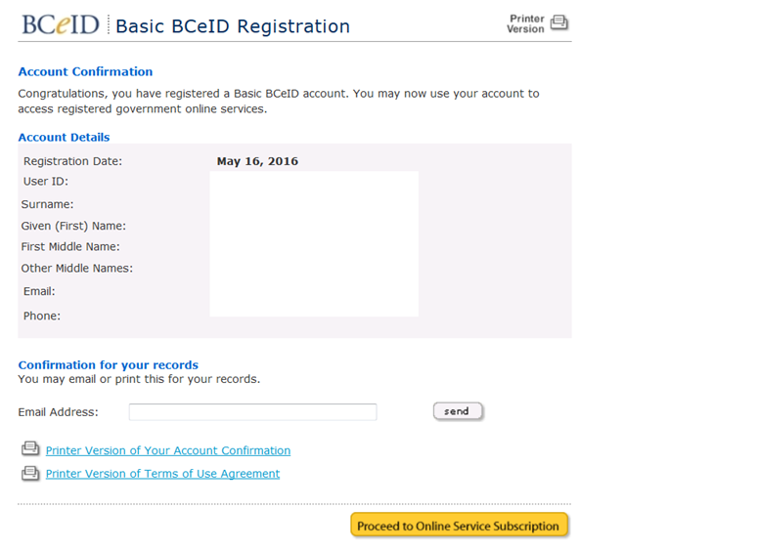

The first page of the Apprentice Application will then appear:

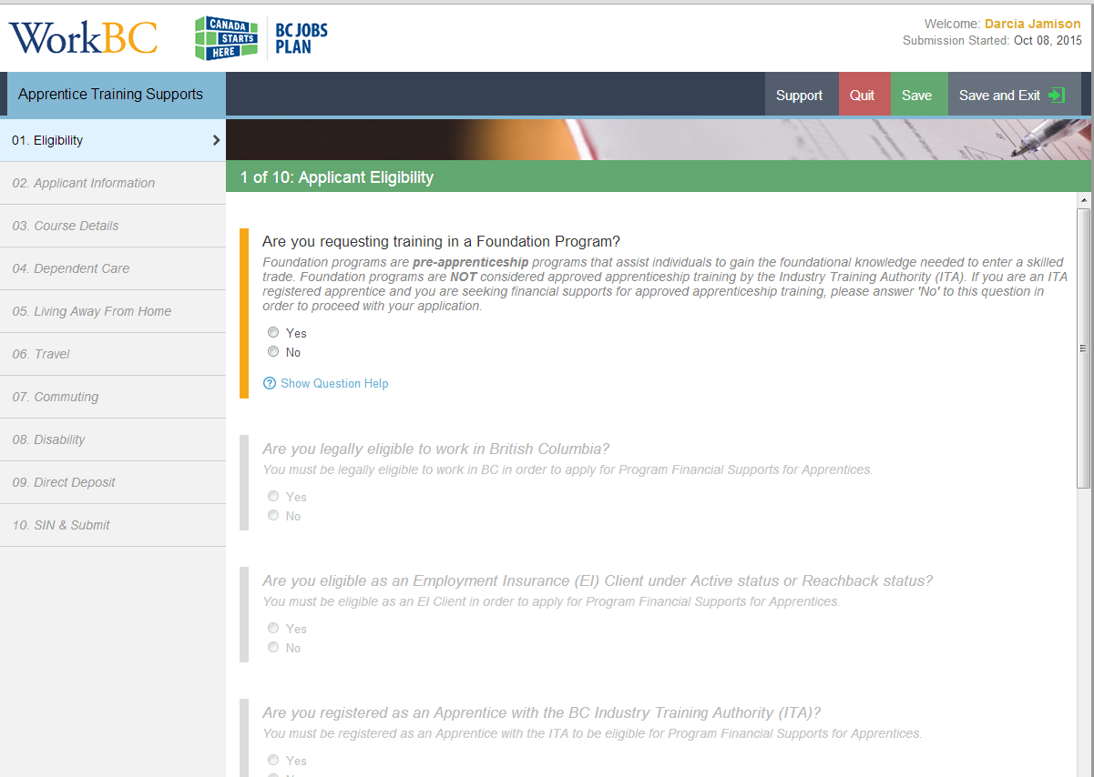

Click the Login & Continue button:

Enter your BCeID and click Next:
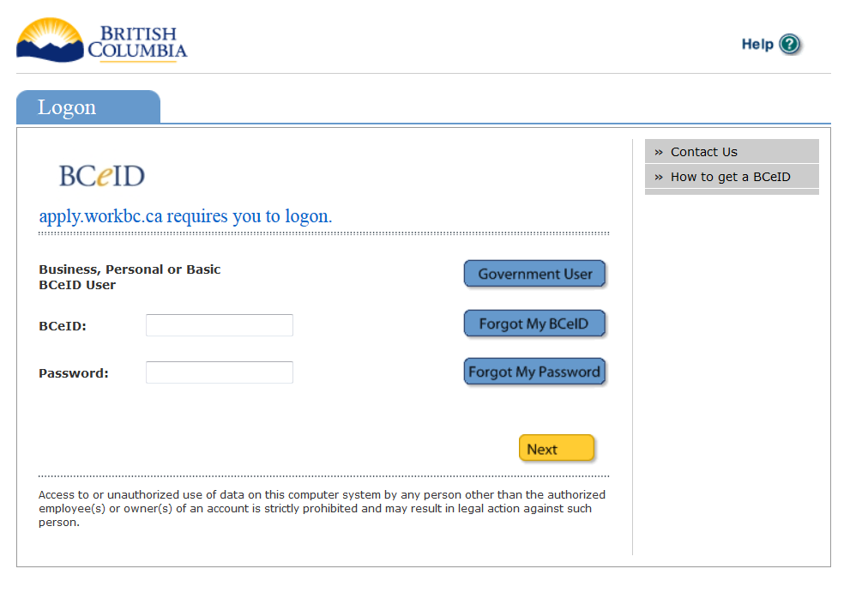

A screen showing previous log in information is displayed; click the yellow Next button again:

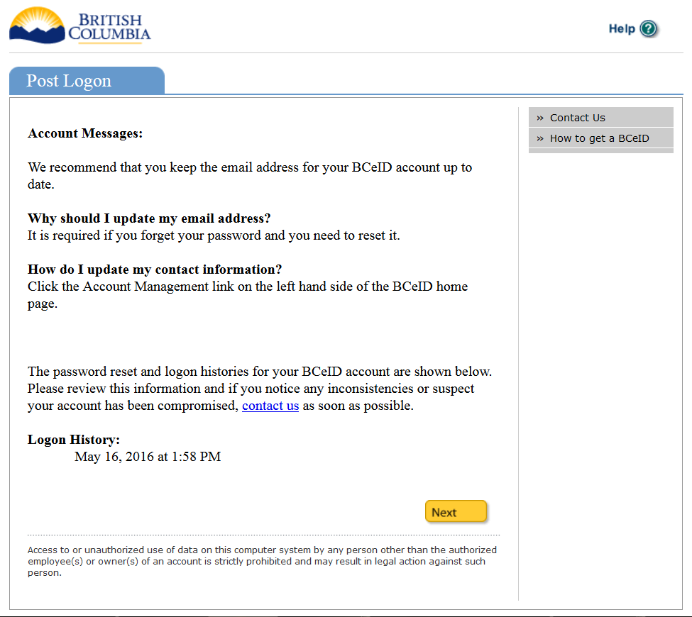

Complete Sections 1 through 10 of the Apprentice Training Supports application then click the Submit Application button on the last page:

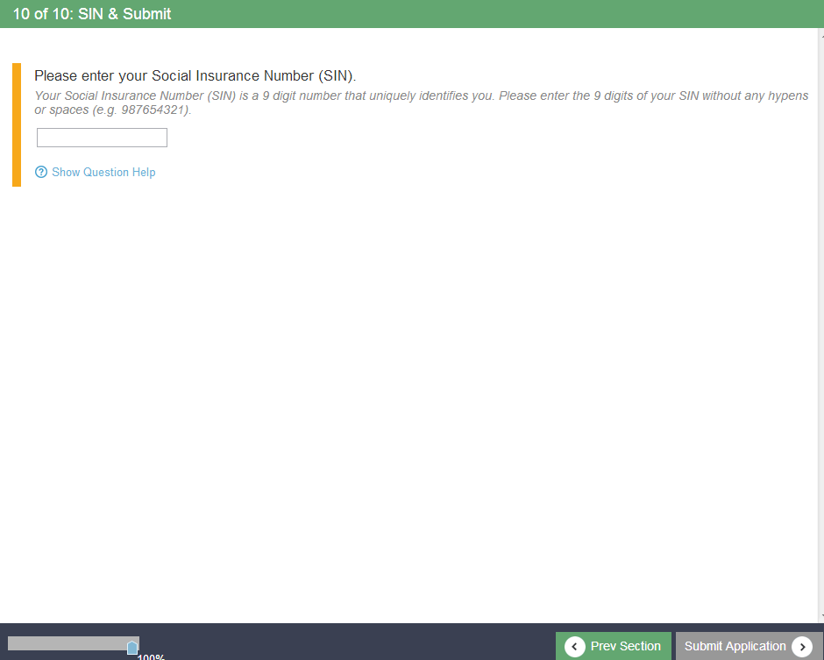

Read the Terms and Conditions and click I Accept:

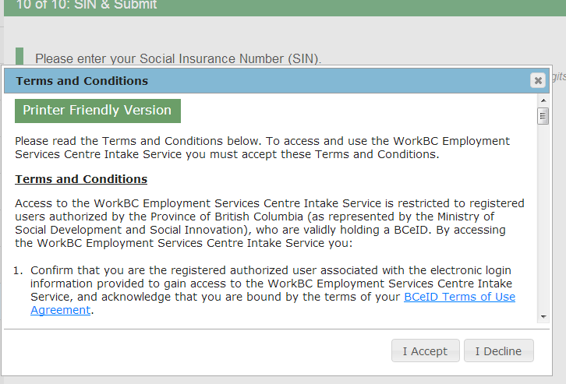

A Submission ID number is generated and the status of the application will show Applied with the date submitted.

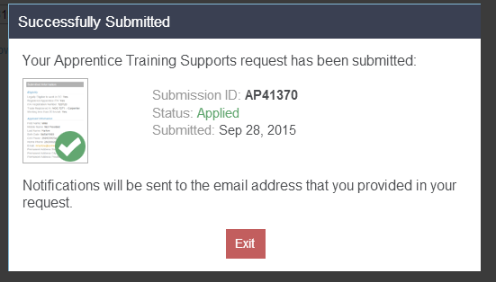

Once the application has been processed by a WorkBC Employment Service Centre, a notification will be sent to the email address provided containing important information about applying for Employment Insurance and an EI Reference Code.

To access the application and obtain the EI Reference code, log back into the Apprentice Supports application using the following methods:

- by using the url link: http://apply.workbc.ca/; or
- by clicking the Access Existing Application button on the main WorkBC page:

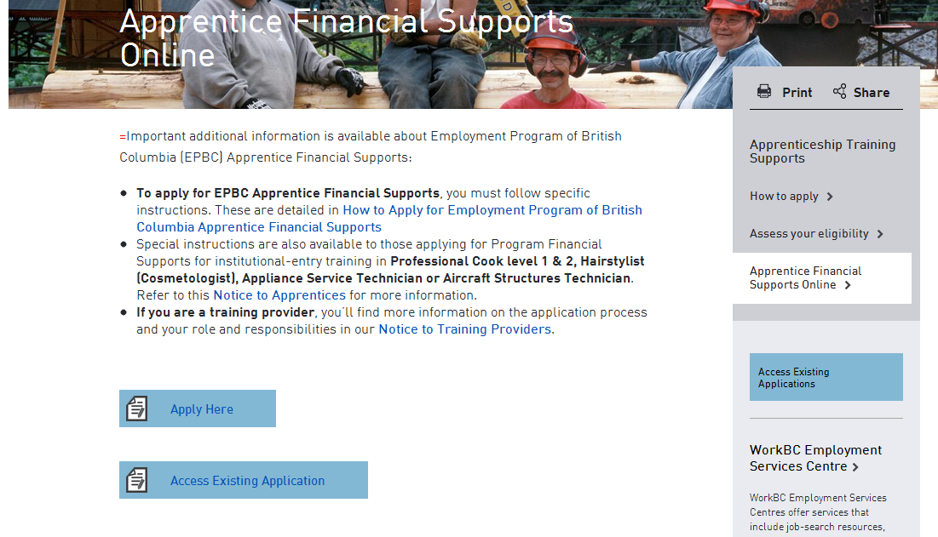

Once logged back into the Apprentice Supports Application, select the EI Reference Code button or View Email Notifications.

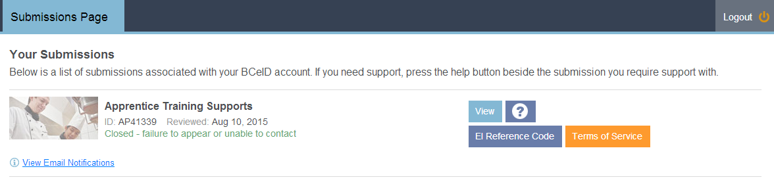
Once you begin attending classes you will receive information regarding your Financial Supports.

Section 2: Complete the Online Application for Employment Insurance Benefits

Step | Action
Step 1. | On the internet, navigate to: http://www.servicecanada.gc.ca; click the applicable language
Step 2. | Beneath the ‘I WANT TO’ section clink on the hyperlink : Apply for Employment Insurance.
Step 3. | This will display a page with information about the process. Once the information has been reviewed, scroll to the bottom of the page and click the red button that says: Start Application
Step 4. | Answer the questions within the application for Employment Insurance Benefits.  - The third question asks ”Were you given a reference code to submit with this application?” Click the radio button: Yes  - Click Continue  - Enter the 16 digit EI Reference Code that obtained upon completion of the Apprentice Supports Application.  Important - The EI Reference Code is a personal and confidential number is needed in order to complete an application for Employment Insurance Benefits. The EI Reference Code should only be used when completing the above process. The number is provided by way of the notification through the Work BC site should not be shared with other students.
Step 5. | Complete the application for Employment Insurance Benefits in its entirety  If assistance is required with the Employment Insurance application process, contact Service Canada.  Once you have completed your application for Employment Insurance and have begun attending classes, your application will be reviewed by your Employment Services Centre (ESC) to determine if you are eligible for any Financial Supports.

